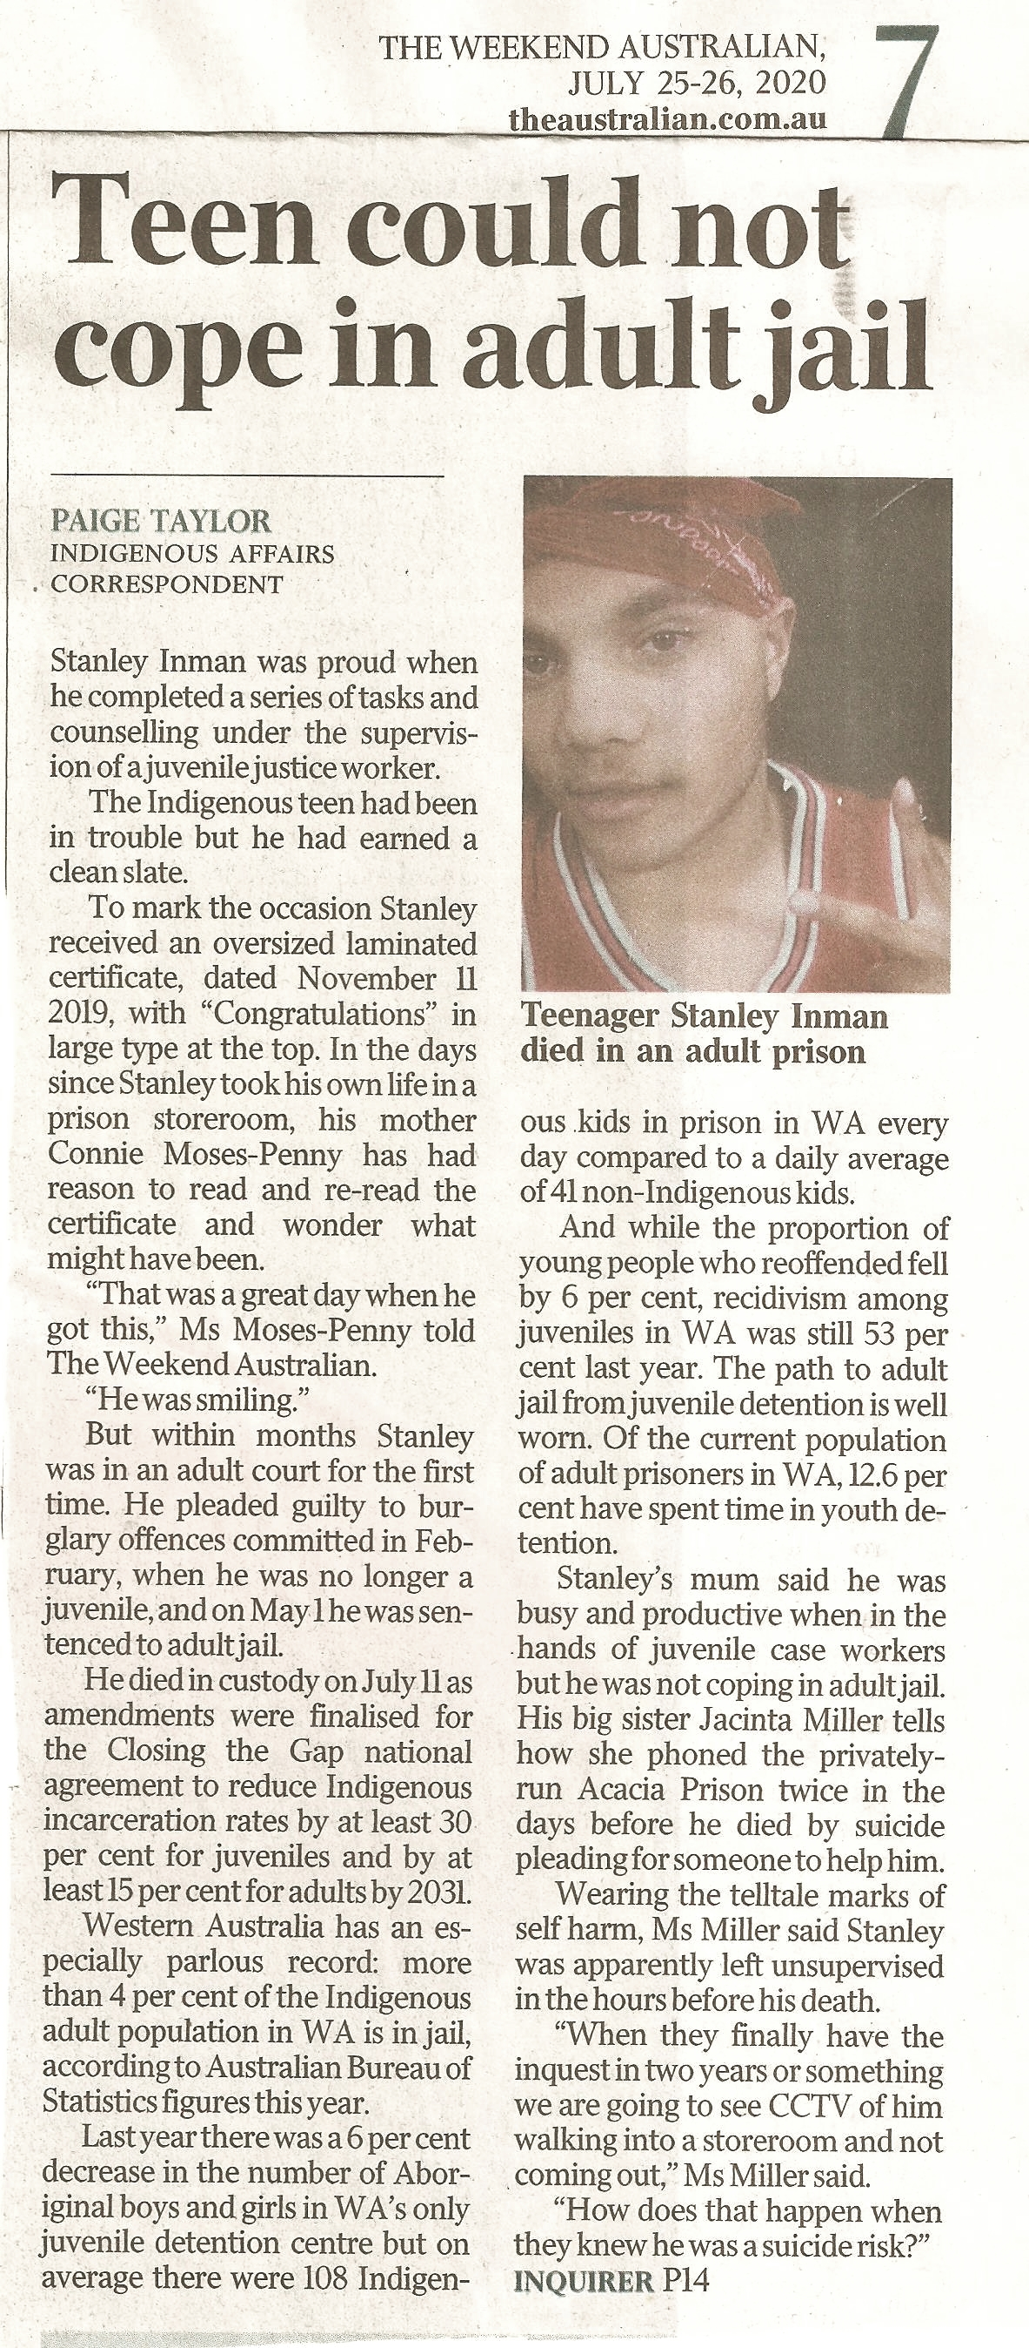
Weekend Australian, July 25-26, 2020, p. 7.
“Teen could not cope in adult jail.”
The 19-year-old son of Connie Moses-Penny died in custody on 11th July, 2020. The teenager’s big sister, Jacinta Miller, had begged for someone at Serco's Acacia Prison to help her brother. She said that when she visited her brother he had visible marks on his body that showed he was hurting himself.
Jacinta told SBS News, “Serco were aware he wasn't coping because you could see it, the physical signs were there.” However, The Weekend Australian writes that her brother was left unsupervised by Serco in the hours before his death.
Paige Taylor reports that on average there were 108 Indigenous kids in prison in WA every day compared to a daily average of 41 non-Indigenous girls and boys. Also, 13 per cent of the Indigenous adult population in WA jails had spent time in youth detention.
Connie Moses-Penny said her son was busy and making progress when in the hands of juvenile case workers. In juvenile detention in November 2019, her son had been presented with a certificate congratulating him for his good work. But months later, after he turned 19, he fronted an adult court for the first time. And in May, 2020, he was sentenced to an adult jail.
In WA the recidivism rate amongst juveniles was 53 per cent last year.
And remember, many, if not most, Indigenous juveniles in detention should not be incarcerated at all.
Note: Stanley's funeral will be held at Fremantle cemetery on August 13, 2020 at 1pm.

Comment: The trial of Graham X was delayed for more than three years, by which time the 15-year-old boy was 18-years-and -8-months of age. After the guilty verdict in November 2006, Graham X spent 4 months in the remand section of the notorious Berrimah prison, during which time his daughter was born. On 22nd March, 2007, only two days before his 19th birthday on 24th March, Graham X was sentenced by Chief Justice Brian Martin to seven years incarceration among violent psychopaths in Berrimah prison. The fact that he served much of the full seven years in punishment cells for maintaining his innocence is a testimony to his courage. Not surprisingly, after his release Graham X remains deeply scarred by his experiences.

